NABARUN SARKAR



 [nabarunsir@gmail.com](mailto:nabarunsir@gmail.com)

 +918906402407

Dedicated and experienced accounting professional with proven success managing ﬁnances for mid-size commercial organizations. Seeking an opportunity to use my 4yrs of experience to serve as a managerial role. Have much knowledge in online marketing and advertising and want to establish myself in a more tough platform than the present one. Need a job where I can prove myself and want to render service to the society.











 C/O- Madhumita Sarkar Chhaatguri

Branch Accounts Head

16-06-2016 - 13-03-2020

ahati Netaji Square Near monosa de corators P.O.+Dist.- Coochbehar Pin- 736101 State-West Bengal





Diploma in Information technology application and certiﬁcate in information technology, diploma and masters in digital marketing, aﬃliate

Joined as a cashier then promoted to Back oﬃce and then Branch Accounts Head in Dhupguri location, handled all branch related work which includes collection, visit NPA customer, non-starter checking. Exception and fraud monitoring

Data entry, Bank Reconciliation and maintaining data MIS.

Business analysis.

NPA Vs Executive checking. Non-starter analysis.

marketing domination.

l

02-03-2015 - 31-08-2015

Windows OS, Ms word, MS excel, Visual FoxPro 6.0, Ms PowerPoint, MS ACCESS , Visual Basic, Internet & Email, C++, VB.net, Java Script and VB script.

Microsoft Oﬃce in details Good knowledge in Microsoft Excel includes VLOOKUP, PIVOT TABLE, PIE CHARTS

AND EXTRAS. Good knowledge in Ms PowerPoint = PPT creation of customer collection Vs executive eﬃciency.

Marketing,sales and customer service with resolution in TAT.

Communication and Negotiation

Leadership- 37 employees were worked under me and got Grade 4.6 in my KRA.

Business Economics and Business Maths Teacher

I was a school teacher for ﬁve months and also a tuition teacher.





Bachelor of commerce 50.50

The complete Financial Analyst Course 2020 95



Diploma in digital marketing 90



10th 62.5

2013

2020

2020

2007

Extra proﬁtable work - I was a topper in Extra work i.e., doing MAS (health insurance) and MLS(loan security insurance). Selling FD to walk in customer. Cross-selling of products online

Having special skills in data science, data science and Machine learning bootcamp with R,

Online marketing and advertising is our priority we have to resolve a query within TAT and have to submit a query by EOD on daily basis. The branch with less query the less the work is then the result can be seen in our KRA.





Date of Birth : 05/06/1991

Tableau 2020 A-Z : Hands-On Tableau Training for Data Science

97

Data Science and Machine learning Bootcamp With R 97

Tally ERP 9

98







Did many works before time and awarded for the same.







Got awarded for the best manager in territory. Got many prizes for FD done by me.

Best data analyst and data MIS handling in pan India.

2nd in cross- selling of products.

2020

2020

2020





Listening music, long drive and many adventures

Playing guitar





I can do any online work with a cup of

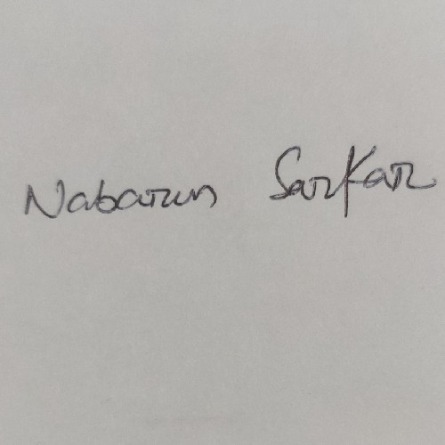



coffee and a laptop in TAT.

Cooking Food Bunjee Jumping

Paraceiling- Got certiﬁcate for this

Reading books

Gardening

CURRENT CTC Rs. 300127 P.A.

NABARUN SARKAR





Gardening

Volunteer in Ramkrishna Math and a devotee of Swami Shibomayananda ji Maharaj. For the same I have to meditate twice a day using guru mantra for spiritual enlightenment on daily basis.

Working in Social welfare and very interested in blood donation camps or so till now donated blood for more 11times.

Watching documentaries.

Reading books Favourite books- PS I love you, jobs, Personality development, the Hobbit, Socerecer stone,Armageddon and The Bhagwad Gita The great gatsby.

LANGUAGE

Read/Speak- English,Hindi,Nepali and Bengali Write- English and Hindi



