**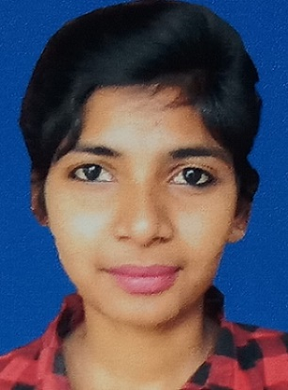**

**SANGITA DAS**

**Email :**sangitad579@gmail.com

**Mobile** +91-8116913808,7908548590,9775160213

|  |
| --- |
| **Career objective** |

To work in a challenging environment using all my skills and efforts to explore in different fields and seek an opportunity for continuous learning & develop new perceptive for the achievement of both organizational and personal growth.

|  |
| --- |
| **Profile** |

**B.Tech**. in **Electronics and Communication Engineering.**

|  |
| --- |
| **Academic Qualification** |

|  |  |  |  |
| --- | --- | --- | --- |
| **Name of Examination** | **Board/University Name** | **Year of Passing** | **Aggregate** |
| B.Tech | MaulanaAbulKalam Azad University of Technology  ( Haldia Institute of Technology, Haldia) | 2019 | 7 DGPA |
| Diploma | W.B.S.C.T.E  (The New Horizons Institute of Technology, Durgapur) | 2016 | 69.6% |
| Secondary Examination | W.B.B.S.E  (P.M Kamala Girl’s high School) | 2012 | 40% |

|  |
| --- |
| **Technical Skill** |

* **Languages Known :** C**,** JAVA, PYTHON
* **Concepts Known :** DATA STRUCTURE

.

|  |
| --- |
| **Achievements and Extra curricular activities** |

* Completed the training on” Machine Learning Using Python.

|  |
| --- |
| **Hobbies** |

* Playing guitar
* Listening Song
* Cooking
* Discovering Something New

|  |
| --- |
| **Personal Profile** |

* **Date of Birth :**26thjune 1997.
* **Father’s Name :** Alok Das.
* **Occupation :**Service**.**
* **Mother’s name :**Monimala Das.
* **Occupation :** Home maker.
* **Sex :**Female.
* **Marital Status :** Single.
* **Language Known** : English, Bengali , Hindi.
* **Permanent Address :**Monoharbohal, P.o-Ethora, P.s-Asansol(N), Dist- Bardhman,

West Bengale, Pin-713359

* **Nationality :** Indian.

|  |
| --- |
| **Strength** |

* Positive attitude.
* Self discipline
* Self-motivating, dedicated to work
* Self-learning and flair to learn new things

|  |
| --- |
| **Declaration** |

**I here by certify that the above information is true and correct for the best of my knowledge and belief.**

**Date: DSC_4049.JPGPlace : ASANSOL (signature)**