 |  | ___________________________Areas of Expertise___________________________
- Leading the creation and maintenance of all databases required for development, testing, education and production usage
- Liaising with Systems Administrators for capacity planning of databases as well as ensuring that new product usage or release upgrade
 | takes place with minimal impact  - Performing on-going tuning of database instances, installing new versions of Relational Database Management System (RDBMS) and other tools that accessed the database  - Planning and implementing measures for backup and recovery of the database; controlling migrations of programs, database changes, reference data changes and menu changes through the development life cycle  - Enforcing security of all the Databases. Maintained database constraints to ensure integrity of the database  - Monitoring database Consistency checks and re-indexing as required assisting |  | 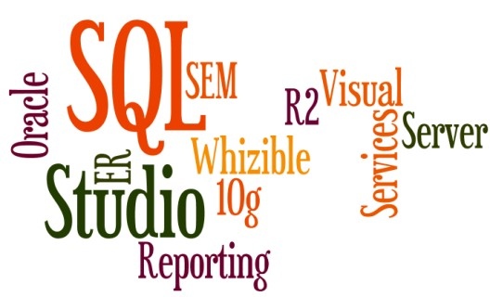
 | performance and ensuring maximum uptime
- Supervising the creation of new database users as required; managing sharing of resources amongst application using Resource
Governor option in SQL Enterprise Editions

Since Nov’16: HDB Finance Limited (Group Entity organisation of HDFC Bank), Mumbai Growth Path:
Since Nov’17 as Deputy Manager
Nov’16 – Nov’17 as Technical Associate

Oct’15 –Nov’16: Clover Infotech Pvt. Ltd. (HDFC Loans & Finance) as Technical Associate

Role:
- Troubleshooting & administering database processes; establishing & maintaining sound backup and recovery policies & procedures on the SQL Server
- Spearheading the management of front-end (ORACLE FORMS, Reports ) Server Administer, Oracle DB Server UAT ,PROD Server administration and performance tuning on query level • Restoring the RMAN backup, as per recommendation
- Orchestrating the ORACLE APEX installation & administration and Tablespace/ user space management, unused space release and shrink
- Spearheading the Oracle Installation, configuration, upgradation of Oracle on Linux Servers in production & development
- Assisting team in resolving business issues, coordinating with various stakeholders; ensuring timely closure of open action items
- Supporting & monitoring the existing infrastructure, supervising preventative maintenance and backup as well as performing other regular support activities to ensure effectiveness
- Creating models for new database development, and made changes in existing databases
- Installing & configuring relevant network components to ensure database access as well as database consistency and integrity • Monitoring, optimizing and allocating physical data storage for database systems
- Planning & coordinating data migrations between systems
- Ensuring minimization of work and changes to prevent disruption to existing business services

Highlights:
HDB Finance Limited
- Undertook a major data redesign which freed database space, saving in disk space costs
- Reduced time taken to generate reconciliation reports from more than a minute through SQL tuning and improvement
- Ensured the integrity and security of enterprise data on host computers, multiple databases, and during data transfer while adhering to privacy, security, and regulatory compliance

Clover Infotech Pvt. Ltd.
- Facilitated the monitoring of server space on production & DR, compilation of PL-SQL code and debugging enable, creation of the scheduled job
- Managed Character Set Migration, scheduling of Cron, statistics gathering for schema-level and enterprise edition ORACLE server
- Created Physical Standby database, Synonym and DB link and AWR & ADDM Report
- Led the logical backup of ORACLE DB server through export import, materialized view refresh

Oct’14 – Sep’15: Softenger India Pvt. Ltd., Pune as Oracle DBA (Level-2) (Client: IDEA Cellular Pvt. Ltd. (IBM Vendor))

Highlights:
Monitored the server status, server space, RAC, Stand-Alone Server with DR issues, CDC subscription; administered DR Recovery, DR, OPATCH application on production, DR and BCV level; conducted daily BCV (FLASHCOPY) & Production to Cloned server; developed AWR, ADDM report, as per user request

Dec’12 – Oct’14: Vyom-Labs & VCC Technologies LLP (Vyom Labs), Pune as Oracle App DBA
Project: Dec’12 – Mar’14: ESSAR Steel, Pune

 | _______________________________Education______________________________
2011 | B. E. (Telecom) from Amravati University
 | _____________________________Personal Details ___________________________
Date of Birth : 21st July 1986
Languages Known : English, Hindi, Arabic (Intermediate) and Marathi
Address : Flat No.-1305, Feinkein Balleza Opp. Anand Nagar Thane-400615
Passport No. : K7533512

