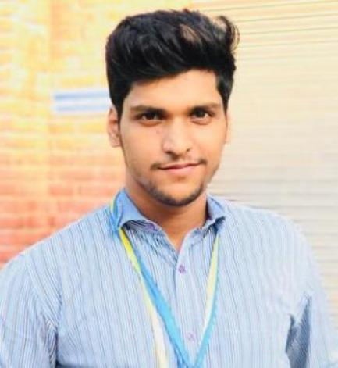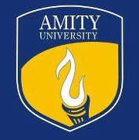

**Address:** sudamapuri opposite shiv mandir morar gwalior

**Mobile:** +917000458058

**Email:** kankarvaibhav42@gmail.com

## CARRER OBJECTIVE

Self-motivated and hardworking fresher seeking an opportunity to work in a challenging environment to prove my technical and interpersonal skills and utilize my knowledge in the growth of the organization

## ACADEMIC QUALIFICATIONS

* Pursuing B.Tech in civil engineering from **Amity University** Gwalior since year 2015, with -7.7 CGPA
* Minor degree in public administration from **Amity University** Madhya Pradesh in 2018
* Intermediate From **S.R convent H.S School**, M.P Board in 2015, with 75.6%.
* Marticulation From **S.T Paul’s school, CBSE** Board in 2013, with 8.4 CGPA

## Academic Achievements And Certifications

* Participated and volunteered seminar on “**National Conference in Emerging trend & Advances in Civil Engineering**” 2017 held Amity University M.P on 31st August 2017.
* Presented paper on **“Earthquake Resistant Building Construction”** in term paper presentation in Amity University.
* Studied **"computer application”** from short courses held by government from madhav institute of technology and sciences.
* Participated in **“international English Olympiad”** .
* Participated in **national science olympiad**
* Verified certification in **AutoCAD** by **Autodesk**.

## TECHNICAL SKILLS

* **Languages:** C, C++, MATLAB
* **Softwares :** AutoCAD

## Summer Internship during UG program

* Company : AK bansal construction

Objective : multi story buildingDuration : 28th may to 10th july

* Company: cad plus pvt. Ltd.   
  Objective: AutoCAD software  
  Duration : 1st June 2017 – 10th July 2017

## Project Undertaken During B.tech program

* Numerical analysis of different types of tunnels.
* Construction of Multi-storey buildings.
* AutoCAD.
* Earthquake resistant building construction.

## Extracurricular & Co-curricular Activity

* Participated in sanghthan amity university 2015,2017
* Got gold medal in kabbadi in Amity Sangathan 2015 held at Amity University, Gwalior.
* One gold, one silver medal in kabbadi 2017, Tug of War 2017
* Got gold medal in Gwalior division karate championship gwalior
* Got bronze medal in inter division karate championship held in shivagi park gwalior
* Participated in state level karate championship.

## Hobbies

* workout
* Soprts
* Listening to music

## Strength

* Adaptive nature, Team player , Professional knowledge , Self Confidence , Leadership Skills

## PERSONAL INFORMATION

**Father’s Name**: Mr. Kuldeep Kankar

**Mother’s Name**: Mrs. Asha Kankar

**Date of Birth**: 24 June 1997

**Language known:** English and Hindi (Conversational level), French (Rudimentary).

## DECLARATION

I hereby declare that all the above information is true to the best of my knowledge and belief.

**Date:**

**Place: VaibhavKankar**