**CURRICULUM VITAE** 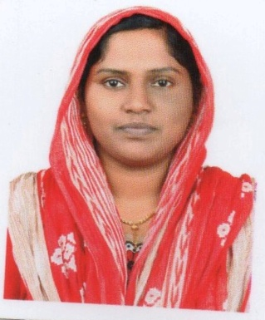

**Career Objective**

**To work sincerely building symbolic relationship with your organization where my efforts will be complimented by career growth, higher degree of responsibility and I am prove myself as a valuable asset for your organization.**

**Educational  Qualification**

|  |  |
| --- | --- |
| **Educational / Professional Qualification:** | |
| |  |  |  |  |  |  |  | | --- | --- | --- | --- | --- | --- | --- | | Sl. No. | Qualification | Specialization | Institution / College | University | Year of passing | % of Marks/Grade | | 1. | SSLC | SSLC | CALICUT GIRLS HIGH SCHOOL | BOARD OF HIGHER SECONDARY EXAMINATION | 2005 | 45 | | 2. | Pre-Degree / +2 | 12th/Plus 2 | CALICUT WOMES COLLAGE | BOARD OF HIGHER SECONDARY EXAMINATION | 2007 | 60 | | 3. | Degree | BA ,SOCIOLOGY | UNITY COLLAGE | CALICUT UNIVERSITY | 2010 | 80 | | 4. | Computer Knowledge | MS OFFICE | UNIQUE |  |  |  | | |
| **Experience:** | |
| |  |  |  |  |  |  |  | | --- | --- | --- | --- | --- | --- | --- | | Sl. No. | Organisation | Designation | Period | Year of Exp | Nature of Work |  | | 1. | UVA TOURS INDIA ,TRADE ARCADE BUILDING YMCA CROSS ROAD ,KANNUR END ,CALICUT 01 | OPERATION MANAGER |  | 5-10 years | TICKETING SECTION |  | | |
| Total Number Experience: | 8 |
| Reference: | Mr.RAJEEV M.S -(MANAGER) ,UVA TOURS INDIA ,TRADE ARCADE BUILDING ,YMCA CROSS ROAD-KANNUR ROAD END ,CALICUT 01 |
| Other relevant information, if any: | NA |
|  | |

**Computer Knowledge**

### MS Office, AMADEUS

### MS Excel

**Languages Known**

**English, Malayalam**

**Hobbies**

**Reading, Watching TV**

**Personal Details**

NAME : SHAHINA TP

NAME OF FATHER : BASHEER N.P

PERMANENT ADDRESS : SHANU MAHAL   
 PANDIPUNATHIL THAZHAM ,PARAMBIL .P.O  
 PARAMBIL BAZAR- 673012

DATE OF BIRTH : 11-03-1989

SEX : FEMALE

NATIONALITY : INDIAN

RELIGION : ISLAM,SUNNY

MARTIAL STATUS : SINGLE

MOB : +91 9142235185

**Declaration:**

I hereby declare that all the information stated above are correct and am    done with the best of my knowledge.

Place: KOZHIKODE                                                            SHAHINA BASHEER

Date: 05/11/2017