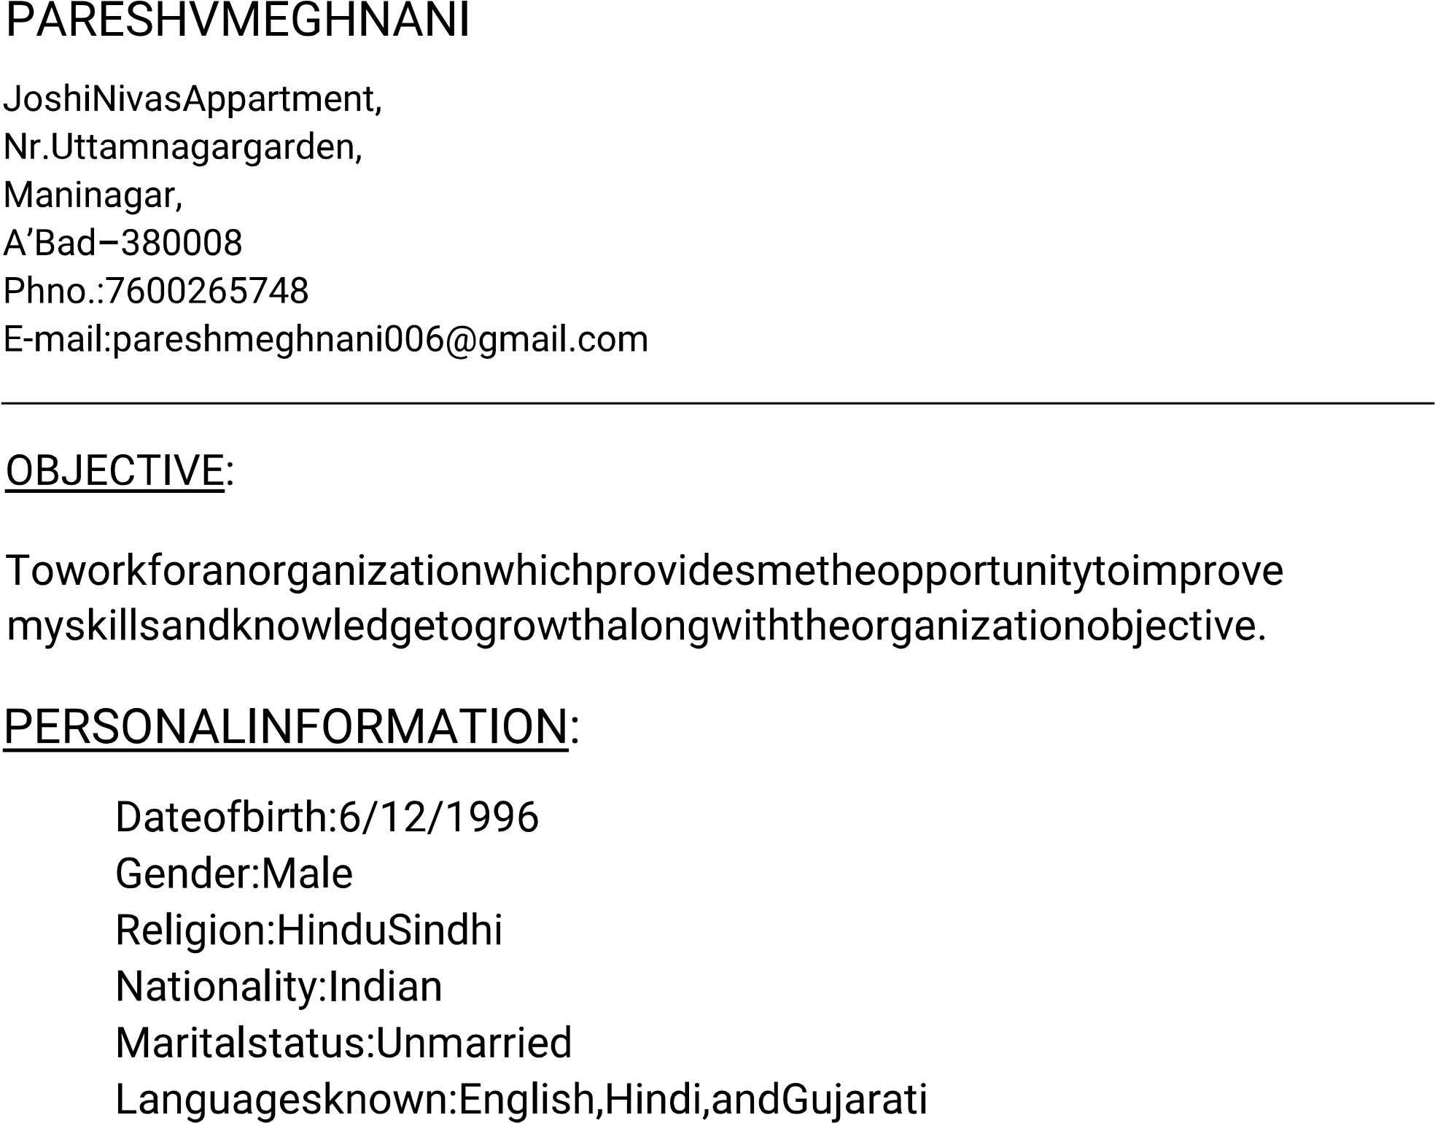

{ From : June 2017 To : April 2018 }

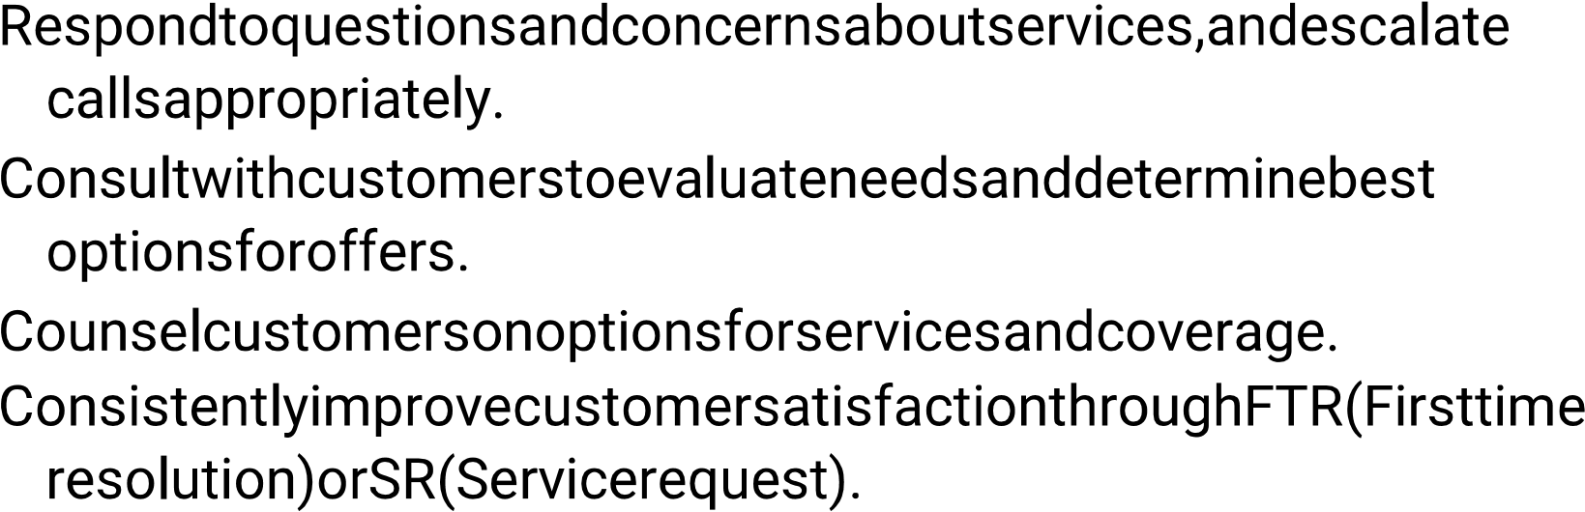

SANTACRUZ PVT L.T.D

{ From : May 2018 To : October 2018 }

To sell the Internet lines and Cables to the small Business firms in USA

{ From : May 2019 / Still Working }



