CURRICULUM - VITAE

Name Sunil Kumar Rana
Date of Birth 30th May 1977

Father's Name Shri Ram Kumar Rana

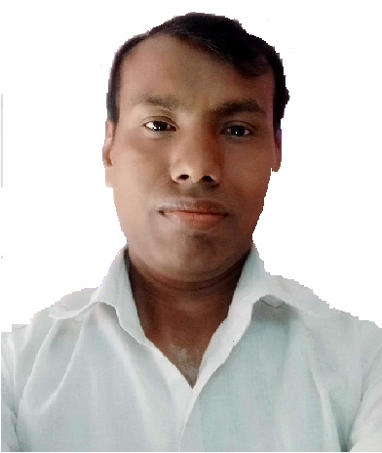

Address H.No 578,
Jwala Nagar, Shahdara, Delhi-32
# 8178083607
Email: sunilrana305@gmail.com

Marital Status Married

Language Known Hindi & English

Academic Qualification
- M. A in Political Science from Delhi University in 2001
- B.A (Pass) from Delhi University in 1997
- 12th Art Stream from CBSE Delhi Board in 1994
- 10th from CBSE Delhi Board in 1992

Professional Qualification
- M.Lib.Sci. from Kurukshetra University in 2003

- B.Lib.Sci. from Kurukshetra University in 2002

- One Year Diploma in Computer programming from new capital college Delhi in 1997

- One Year Diploma in Computer software from BIT, N. C. T. Govt. of Delhi in 2001

- Training of LibSys Library software by LibSys Corporation Ltd Gurgaon.

Specialisation
- Maintain all database in Access or Excel
- Worked with LibSys Library Software in NDIM Library.
- Classification DDC, UDC, CC & Catalouguing AACR 2, CCC
- Subject Heading by Sears list

Computer Proficiency
- Operating System Windows; work with latest version 10
- Internet Services E-mail, work with Search Engines etc.

Tech. Qualification
- One Year Certificate in Store keeping & Purchasing from C S P I, B P I Delhi
- English Type Test passed Delhi Employment Exchange Speed 35 W.P.M
- English Typing Speed 8000 K.D.P.H in computer typing

EXPERIENCE : 13 + years
- My last job working organization was New Delhi Institute of Management ( Affiliated by AICTE, AIU Delhi ) at 50 (B & C ) Tuglakabad institutional Area Delhi 110062. I had working as an Assistant Librarian with NDIM since Dec. 2008 to Oct. 2017.
Job Profile In Library:
* Acquisition work of each semester wise.
* Accession of New Books in Accession register.
* Classification and Cataloguing in LibSys Library software.
* Making Spin Label, Bar Code Label, Book Property Label By Libsys Software.
* Serials/Periodicals Subscription & Renewal Annually and entry in Libsys software.
* Circulation look after Time to Time.
* Binding works of Books, Serial & Periodicals By annually.
* Help to library users query in web search and EBESCO-Database software etc..
(II) Also I had worked in Academic department from 2014 to 2017:
- look after all academic jobs like;
- classes arrangement,
- prepare of Students attendance recods,
- issued all bonafide certificates to students,
- submitted and maintain all students records of summer and winter project reports,
- prepare students debar list from the exams,
- float the time table daily basis and class arrangement for changes in time table and etc. lot of jobs assign in academic department.
- Worked with Hi-Tech Institute of Engineering & Technology, Affiliated to UP Technical University, Lacknow as Librarian Since September 2006 to November 2008 at Plot no. 766, Delhi Hapur Bye- Pass Road, 26th mile stone N.H. - 24 (Near Lalkuan ), Ghaziabad (U.P.) 201002

- Worked with New Delhi Institute of Management Affiliated by GGS Inderprastha University Delhi as Jr. Assistant Librarian Since December 2004 to August 2006 at 60-61 Tuglakabad institutional Area Delhi 110062.

Declaration: I hereby declare that the above information is factually correct to the best of my knowledge & Belief.
Date: May-2022 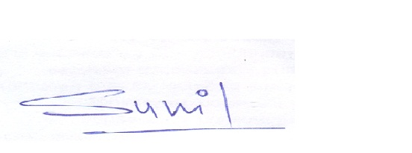
Place: Delhi (Sunil Kumar Rana)

