**CURRICULUM VITAE** 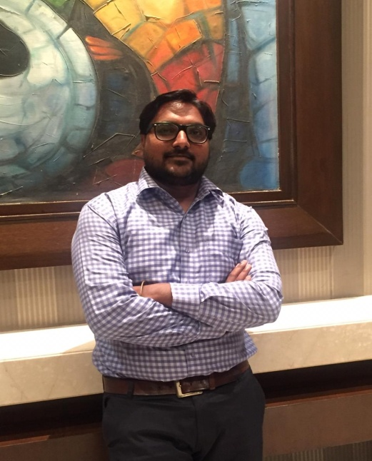

**Senior Architect**

**Ar. Mahendra Malviya**

**(C.O.A. No. - CA/2013/60299)**

**House No. - C 1128 , P.D.D.U.**

**NAGAR,SUKHLIYA,Indore(M.P.**)

Cont,No. :- 09098611559

E-mail id : [archicool06@gmail.com](mailto:archicool06@gmail.com%20%20%20%20%20)

**OBJECTIVE :-**

My Vision is to perform and give my best to the field of architecture working with experienced personnel, to work in a challenging environment where knowledge, with the growth of organization.

**PROFESSIONAL PROFILE:-**

* Highly analytical team player with aptitude for quickly scrutinizing environments to identify and prioritize needs/risks and develop solutions.
* Highly flexible and adaptable performer; adept at multi-tasking and thriving in a fast-paced environment while coordinating numerous time-sensitive projects.
* Energetic, competitive achiever who can inspire and motivate team members, successfully manage multiple priorities, and perform under pressure in a fast-paced, rapidly changing environment.

**Work Experience:-**

* **AADHARSHILA DESIGN STUDIO_INDORE. (JUNE-2011)**
* **HIRSCH BEDNER ASSOCIATESNEW DELHI.(JUNE-2012)**
* **M.A. ARCHITECT PVT. LTD._JAIPUR. (AUG-2013)**
* **VENUGOPALASSOCIATES_UDAIPUR. (JAN-2015)**
* **KAMAL HINGED CONSTRUCTION & CONSULTANT PVT. LTD._UDAIPUR.(JUNE-2015)**
* **KAPIL JAIN & ASSOCIATES_INDORE.. (JUNE-2017)**

**Total 8 Years Experience.**

**Job Profile:-**

* Planning scheduling and monitoring.
* Preparation of Design and its presentation.
* Estimating & execution of work.
* Site organization and planning for the upcoming works.
* Coordination with different discipline for execution.
* Resources management.
* Independent work of project handling and executing.
* Dealing with clients.
* Co-ordination of different services in design

**Educational Qualification:-**

|  |  |  |  |
| --- | --- | --- | --- |
| **Exams** | **Board/College** | **Passing Year** | **Percentage** |
| B-arch | M.I.T.S. Gwalior | June 2011 | 65 |
| HSC(12th) | MP Board Bhopal | Dec 2004 | 61.66 |
| SSC(10th) | MP Board Bhopal | 2002 | 64.50 |

**Projects:-**

**AADHARSHILA DESIGN STUDIO, INDORE (M.P.)**

**(JUL-2011 TO JUN-2012)**

* Residential Apartment, Aren Construction Pvt.Ltd. (INDORE)
* Row Housing, Lilani Constructions at Bijalpur, (INDORE)
* Residential Apartment, Lilani Constructions at Bijalpur, (INDORE)
* Vilas, Apollo Creations Pvt.Ltd.(INDORE)

**HIRSCH BEDNER ASSOCIATES** , **NEW DELHI**

**(JUN-2012 TO AUG-2013)**

* Interior Designing Hotels
* Furniture Designing
* Fixture Designing
* Floorings, RCP, Toilet Details & interiors.

**M.A.ARCHITECTS Pvt.Ltd. JAIPUR (RAJASTHAN)**

**(AUG-2013 TO DEC-2015)**

* Pearl Avantika (Highend Apartment) Jaipur
* Rajasthan Housing Board (HIG, MIG, Tower Jaipur)
* Kalpturu Builder Bombay (High End Apartment Jaipur)

**VENUGOPAL ASSOCIATES UDAIPR (RAJASTHAN)**

**(JAN-2015 TO DEC-2016) PART TIME JOB**

* Arvana Commercial Building IKP Builders at Udaipur
* RMI City Center Commercial Building at Udaipur
* Gajraj Ji Traditional Residence Bungalow at Udaipur
* AmritJwellers Residence at Udaipur
* Dr.Pankaj Trivedi Residence at Udaipur
* Resort in Balicha at Udaipur

**KAMAL HINGED CONSTRUCTION & CONSULTANT PVT. LTD ,UDAIPR(RJ.) (JUN-2015 TO JUN-2017)**

* Heritage building public complex at NAKODA JI.
* B+G+5 Hostel Building at jodhpur.
* Heritage International School at Nathdwra, Udaipur. Raj.
* Heritage Bus Stand Building at Nakodaji.
* Apartment at Nathdwara ,Udaipur. Raj.
* Affordable housing project at Udaipur. Raj.
* Smart Study International School at Nathdwra(Udaipur)

**KAPIL JAIN AND ASSOCIATES,INDORE ( JUNE-2017)**

* Premium Tower, Race course road at Indore. (running)
* Pakiza Green Township , ews & lig tower at Indore. (running)
* Apartment Race course , at Indore. (running)
* Kalindi Township , at Indore. (complete)
* Ras Lack View Township, at Indore. (complete)
* ENT Hospital with Dr.Residence, at Barwani. (running)
* Auditorium Design at Raipur.(Govt.Tender C.G. PWD)
* Auditorium Design at Bilaspur.(Govt.Tender C.G. PWD)
* BAKEWELL OUTLET IN FABRICATION . (MR-10, INDORE)
* District Court Design at khargoane.(Govt.Tender MPPWD)
* District Court Design at Sanawad.(Govt.Tender MPPWD)
* District Court Design at Badawah.(Govt.Tender MPPWD)
* HOTEL CROWN PALACE RENOVATION. (INDORE)
* All Type of Govt. Projects in Madhyapradesh&Chhatisgarh.

**College Project:-**

1st-sem : 2d & 3d color composition, furniture design

2nd-sem : kiosk, bus stand, grill & railing design

3rd-sem : Residence, Pyramid house, Nursery school

4th-sem : Primary school, Residence

5th-sem : Student activity centre, Two Wheelers Showroom

6th-sem : Housing including apartment, duplex, ews. nursing home,

Restaurant

7th-sem : Health spa, IT institute

8th-sem : Professional training (Creative Designers Nehru place)

9th-sem : Apartment housing and Management institute

10th-sem : MaharanaPratap Khel gaoun cum sports complex at

udaipur.

**Nasa activities:-**

Annual NASA :2006 Nari Gandhi trophy.

Manipal Annual NASA : 2007 LIK trophy Bhopal.

Annual NASA :2008 hudcco trophy (reconstruction EWS

quarter in Gwalior

**Computer Proficiency:-**

Operating system : MS Windows 2000, MS XP, Windows Vista and

Windows 7

Software : Auto CAD- 04-10(Architect)

M.S.Office and Acrobat professional.

**Other Details:-**

No of paper publish : 0 times

Sports : Wholly Ball Divisional player,

Cultural programs Divisional level

Various Athletic Sports activity

**Personal Profile:-**

Father’s Name : Late Shri MadhavLalMalviya Permanent

Address : M 2nd/80 New Indira Nagar Neemuch M.P.

Phone No. : None

Mobile No : +91-9098611559

Marital Status : Married

Date of Birth : 22/04/1986

Languages known : Hindi, English(learning)

Hobby : Music listening, traveling

**C.T.C :-**

**Current C.T.C : 50000 / Month**

**Notice Period : 1 Month**

**Date 20/ 08/ 2019**

**I hereby declare that above mentioned information is true and best of my knowledge.**

---------------------x--------------x-----------x------------------------