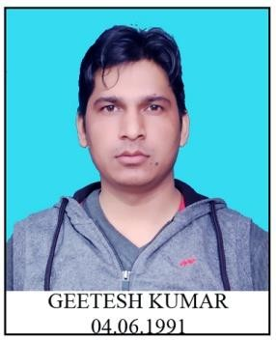
CURRICULUM- VITAE

GEETESH KUMAR

CAREER OBJECTIVE:
G-71 EAST VINOD NAGAR EAST DELHI -110091 MOBILE NO-8800701712
Email – geeteshkumar@gmail.com

Seeking a satisfying career where I can utilize the essential elements of my qualification, experience, personal skills,interest& direct them towards the success.

EDUCATIONAL QUALIFICATION:

- B.A (Hindi Hons) from Dr. BR. AMBEDKAR University AGRA (Appearing)
- 12th Passed from U.P. BOARD
- 10th Passed from U.P. BOARD

TECHINICAL QUALIFICATION:

- Basic Knowledge of Computer in Ms-Office & Social Media.

WORKING EXPERIENCE
- Worked as a Daily wager in Directorate of Film Festival (DFF) from 3rd June to 31st may 2018
- Worked for 64^{th,} 65th & 66th National Film Awards in DFF as a Coordinator for smooth functioning of Jury Screenings.
- PFMS, Coordinated with many callers for Online Entry – National Film Awards, maintaining office files end other important documents Etc.

- Worked with Indian Panorama 2018 in Delhi and Coordinated with the applicants for online submission of entries and Bharatkosh Payment.
- Worked with 45th, 46^{th,} 47^{th,} 48th & 49th International Film Festival of India, Coordinated with Preview committee Jury, Delegate Registration and maintaining of office files.
- Worked with 1st BRICS Film Festival in Delhi as a Jury Assistant

POTENTIAL

- Flexibility & Empathic Learner,
- Hard Working with Positive Attitude

PERSONAL INFORMATION
Father’s Name : Shri Bijendra Singh
Date of Birth : 4th Jun.1991
Gender : Male
Marital status : married
Religion : Hindu
Nationality : Indian
Languages Known : English, Hindi

DECLARATION;
I hereby declare that all that above information is true to the best of my knowledge and belief.

Date : .03/05/2019
Place: Delhi (GEETESH KUMAR)

